VOCABULARY WORK:
The Academic Word List

Section A: headwords of the AWL list - edited version to facilitate learning

- On your smartphone, you can use the AWL builder application to hear the pronunciation of words and read a definition of each word:
https://play.google.com/store/apps/details?id=com.CB.AWLBuilder_global

- On your computer, you can also look at the table further below (semester 2) and click on the words underlined in blue in the first column to access the definition and pronunciation directly online.

- On Moodle, you have links to Quizlet lists to review with flashcards and interactive activities.

* The list on the next 2 pages has been edited to help you learn more efficiently *
- Words which are highlighted are “faux-amis” or have irregular plurals
- Words in bold are probably new to you.
You should still read ALL words and make sure you know the ones which are not in bold as well.

* The list on the following 2 pages has been edited to help you work on pronunciation *
- Indications to help with pronunciation have been added below some words.
(If you are not familiar with phonetic transcription, read the lessons on pronunciation on the Moodle group Ressources apprentissage d’anglais)
- You also have a recorded version of the full list online – listen to it to help memorize the correct pronunciation!

STUDY PROGRAM:
L2 B1 & B2 S1: AWL headwords 1st part ( until “internal”)
L2 B1 & B2 S2: AWL headwords full list
L3 B2&C1 S1+S2: AWL headwords full list

* Remember that LEARNING a word means learning
its SPELLING and PRONUNCIATION in addition to its meaning!

abandon abstract academy access accommodate accompany accumulate accurate achieve acknowledge 10 acquire adapt adequate adjacent adjust administrate adult advocate affect aggregate 20 aid albeit allocate alter alternative ambiguous amend analogy analyse annual 30 anticipate apparent append appreciate approach appropriate approximate arbitrary area aspect 40 assemble assess assign assist assume assure attach attain attitude attribute 50 author authority automate available aware behalf benefit bias bond brief 60 bulk capable capacity category cease challenge channel chapter chart chemical 70 circumstance cite civil clarify classic clause code coherent coincide collapse 80 colleague commence comment commission commit commodity communicate community compatible compensate 90 compile complement complex component compound comprehensive comprise compute conceive concentrate 100 concept conclude concurrent conduct confer confine confirm conflict conform consent 110 consequent considerable consist constant constitute constrain construct consult consume contact 120 contemporary context contract contradict contrary contrast contribute controversy convene converse 130 convert convince cooperate coordinate core corporate correspond couple create credit 140 criteria crucial culture currency cycle data debate decade decline deduce 150 define definite demonstrate denote deny depress derive design despite detect 160 deviate device devote differentiate dimension diminish discrete discriminate displace display 170 dispose distinct distort distribute diverse document domain domestic dominate draft 180 drama duration dynamic economy edit element eliminate emerge emphasis empirical 190 enable encounter energy enforce enhance enormous ensure entity environment equate 200 equip equivalent erode error establish estate estimate ethic ethnic evaluate 210 eventual evident evolve exceed exclude exhibit expand expert explicit exploit 220 export expose external extract facilitate factor feature federal fee file 230 final finance finite flexible fluctuate focus format formula forthcoming foundation 240 found framework function fund fundamental furthermore gender generate generation globe 250 goal grade grant guarantee guideline hence hierarchy highlight hypothesis identical 260 identify ideology ignorance illustrate image immigrate impact implement implicate implicit 270 imply impose incentive incidence incline income incorporate index indicate individual 280 induce inevitable infer infrastructure inherent inhibit initial initiate injure innovate 290 input insert insight inspect instance institute instruct integral integrate integrity 300 intelligence intense interact intermediate internal interpret interval intervene intrinsic invest 310 investigate invoke involve isolate issue item job journal justify label 320 labour layer lecture legal legislate levy liberal licence likewise link 330 locate logic maintain major manipulate manual margin mature maximise mechanism 340 media mediate medical medium mental method migrate military minimal minimise 350 minimum ministry minor mode modify monitor motive mutual negate network 360 neutral nevertheless nonetheless norm normal notion notwithstanding nuclear objective obtain 370 obvious occupy occur odd offset ongoing option orient outcome output 380 overall overlap overseas panel paradigm paragraph parallel parameter participate partner 390 passive perceive percent period persist perspective phase phenomenon philosophy physical 400 plus policy portion pose positive potential practitioner precede precise predict 410 predominant preliminary presume previous primary prime principal principle prior priority 420 proceed process professional prohibit project promote proportion prospect protocol psychology 430 publication publish purchase pursue qualitative quote radical random range ratio 440 rational react recover refine regime region register regulate reinforce reject 450 relax release relevant reluctance rely remove require research reside resolve 460 resource respond restore restrain restrict retain reveal revenue reverse revise 470 revolution rigid role route scenario schedule scheme scope section sector 480 secure seek select sequence series sex shift significant similar simulate 490 site so-called sole somewhat source specific specify sphere stable statistic 500 status straightforward strategy stress structure style submit subordinate subsequent subsidy 510 substitute successor sufficient sum summary supplement survey survive suspend sustain 520 symbol tape target task team technical technique technology temporary tense 530 terminate text theme theory thereby thesis topic trace tradition transfer 540 transform transit transmit transport trend trigger ultimate undergo underlie undertake 550 uniform unify unique utilise valid vary vehicle version via violate 560 virtual visible vision visual volume voluntary welfare whereas whereby widespread

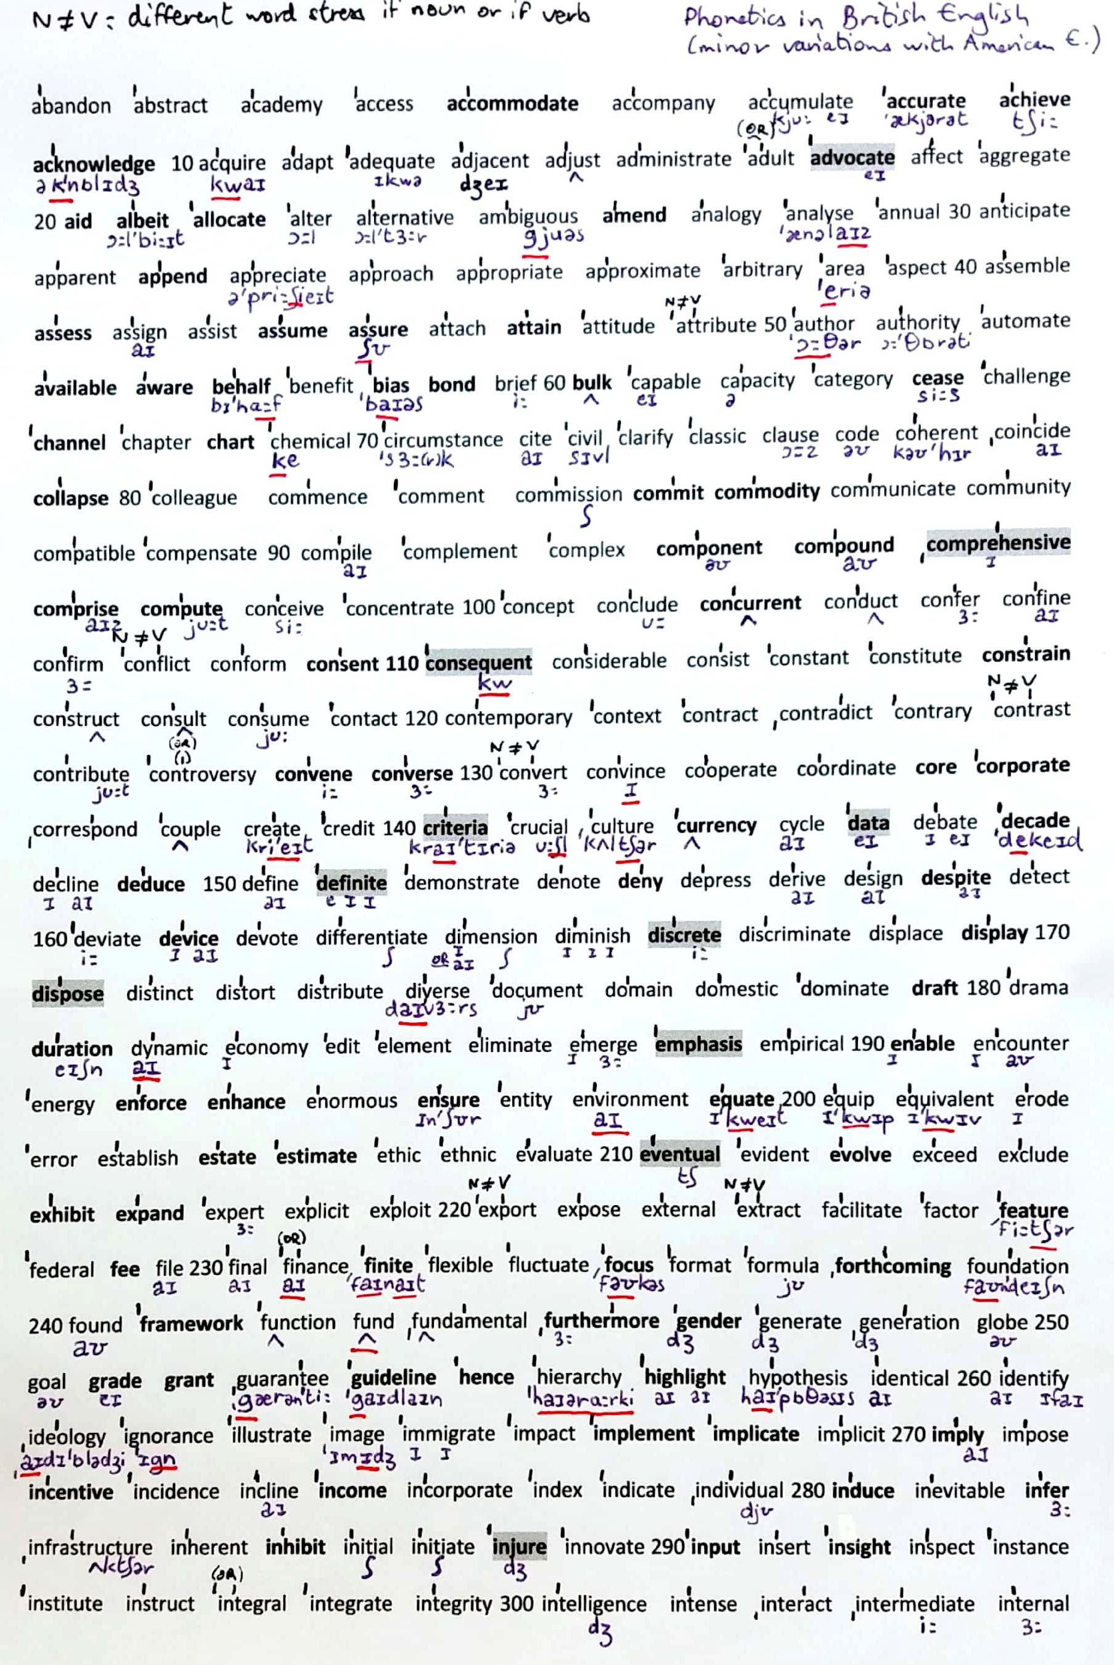
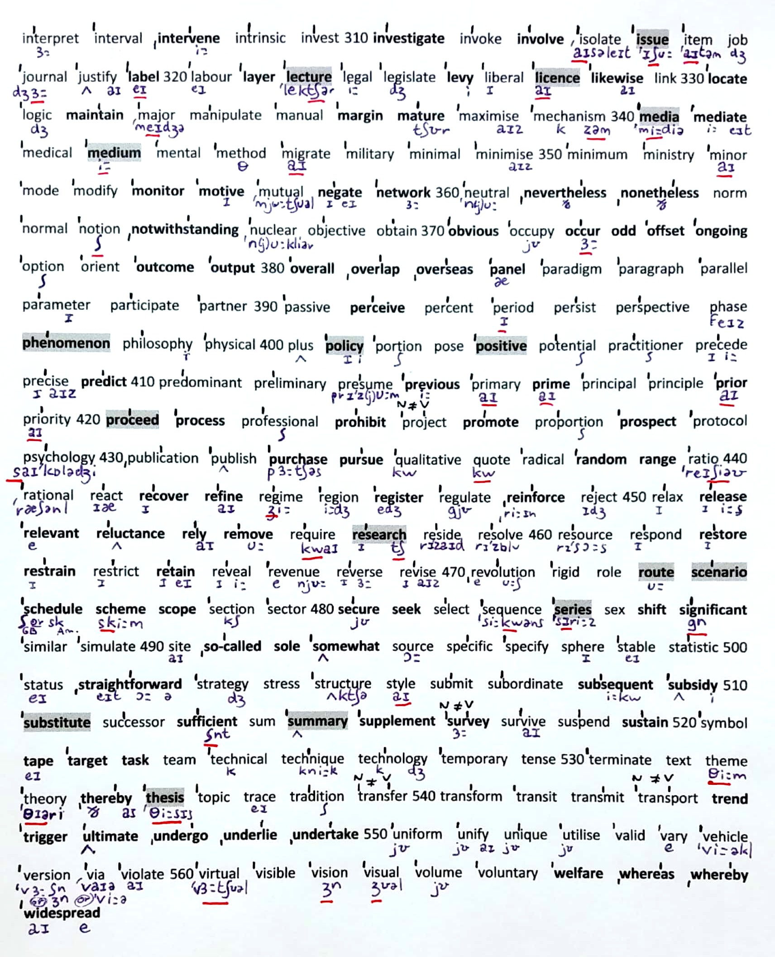

Section B: AWL full list (headwords and related subwords)

Edited version, adapted from http://www.uefap.com/vocab/select/awl.htm
(NB : British spelling is used in the list below) - *Definitions linked to the online Cambridge Dictionary

* IN THE EDITED TABLE BELOW, TO FACILITATE LEARNING, ALL CONJUGATED AND PLURALS FORMS HAVE BEEN REMOVED FOR A SIMPLIFIED LIST
(unless they are irregular plurals or verbs) *
(for instance: abandons, abandoned, abandoning have been removed)

- On your computer, you can look at the table below and click on the words underlined in blue in the first column to access the definition and pronunciation directly online.

- On Moodle, you have links to Quizlet lists to review with flashcards and interactive activities.

STUDY PROGRAM:
L3 B1 S1: AWL subwords 1st part ( until “internal”)
L3 B1 S2: AWL subwords full list
L3 B2&C1 S1 & S2: AWL subwords full list

USE THIS LIST TO PRACTICE PRONUNCIATION AND WORD STRESS AS WELL
practice reading the words aloud and putting the stress on the appropriate syllable

PRONUNCIATION – STRESS PATTERNS
Each word has a primary stress: /ˈestɪmət/ and sometimes also a secondary stress: /ˌʌndərˈestɪmeɪt/
Prefixes usually don’t change the stress pattern: ˈadequate => inˈadequate ; ˈalter => unˈaltered
Suffixes fall into two categories : neutral or stress-assigning.

NEUTRAL suffixes don’t change the stress pattern :
-s, -ed, -ing (conjugations), -able, -ive (adjective), -ly (adverbs)
-er (comparative), -est (superlative), -ment , -ist, -ism, -ness (nouns)
Ex : aˈbandons, aˈbandoned, aˈbandoning are all stressed on ‘ban
Aˈchieve => aˈchievable, aˈchievement
Disˈtinct => disˈtinctive
ˈNational => ˈnationally, ˈnationalist, ˈnationalism

STRESS-ASSIGNING suffixes change the stress pattern, in a regular way :
-ic , -ical , -ity , -ion = stress on the syllable before the prefix
Ex: aˈnalysis but anaˈlytical ; ˈnational but natioˈnality
Ex: acˈcommodate but accommoˈdation; ˈauthor but auˈthority
Ex: ˈcommon but comˈmunity and communiˈcation

******

To access the full unedited sublist, and to do exercises on the list, you can use the following links:
- Full list by sublists: https://www.oxfordlearnersdictionaries.com/wordlist/english/academic/
- Exercises on the AWL: http://www.englishvocabularyexercises.com/AWL/id17.htm

******

Words in bold in the right column need to be learnt with particular attention.
You should still read and know the entire list!

Headwords  & link to definition* | Subwords - Other words in the family
abandon | abandonment
abstract | abstraction, abstractly
academy | academia, academic, academically, academics
access | accessibility, accessible, inaccessible
accommodate | accommodation
accompany | accompaniment, unaccompanied
accumulate | accumulation
accurate | accuracy, accurately, inaccuracy, inaccurate
achieve | achievable, achievement
acknowledge | acknowledgement
acquire | acquisition
adapt | adaptability, adaptable, adaptation, adaptive
adequate | adequacy, adequately, inadequacy, inadequate, inadequately
adjacent
adjust | adjustment, readjust, readjustment
administrate | administration, administrative, administratively, administrator
adult | adulthood
advocate | advocacy
affect | affective, affectively, unaffected
aggregate | aggregation
aid | unaided
albeit
allocate | allocation
alter | alterable, alteration, alternate, alternating, unalterable, unaltered
alternative | alternatively
ambiguous | ambiguity, unambiguous, unambiguously
amend | amendment
analogy | analogous
analyse | analyser, analyses, analysis, analyst, analytic, analytical, analytically
annual | annually
anticipate | anticipation, unanticipated
apparent | apparently
append | appendix, appendices, appendixes
appreciate | appreciable, appreciably, appreciation, unappreciated
approach | approachable, unapproachable
appropriate | appropriacy, appropriately, appropriateness, inappropriacy, inappropriate, inappropriately
approximate | approximately, approximation
arbitrary | arbitrariness, arbitrarily
area
aspect
assemble | assembly
assess | assessable, assessment, reassess, reassessment, unassessed
assign | assignment, reassign, unassigned
assist | assistance, assistant, unassisted
assume | assumption
assure | assurance, assuredly
attach | attachment, unattached
attain | attainable, attainment, unattainable
attitude
attribute | attributable, attribution
author | authorship
authority | authoritative
automate | automatic, automatically, automation
available | availability, unavailable
aware | awareness, unaware
behalf
benefit | beneficial, beneficiary
bias | unbiased
bond
brief | brevity, briefly
bulk | bulky
capable | capability, incapable
capacity | incapacitate
category | categorisation, categorise, categorizing
cease | ceaseless
challenge | challenger
channel
chapter
chart | uncharted
chemical | chemically, chemicals
circumstance
cite | citation
civil
clarify | clarification, clarity
classic | classical, classics
clause
code
coherent | coherence, coherently, incoherent, incoherently
coincide | coincidence, coincident, coincidental
collapse | collapsible
colleague
commence | commencement, recommence
comment | commentary, commentator
commission | commissioner
commit | commitment
commodity
communicate | communicable, communication, communicative, communicatively, uncommunicative
community
compatible | compatibility, incompatibility, incompatible
compensate | compensation, compensatory
compile | compilation
complement | complementary
complex | complexity
component | componentry
compound
comprehensive | comprehensively
comprise
compute | computation, computational, computable, computer, computerised
conceive | conceivable, conceivably, inconceivable, inconceivably
concentrate | concentration
concept | conception, conceptual, conceptualisation, conceptualise, conceptually
conclude | conclusion, conclusive, conclusively, inconclusive, inconclusively
concurrent | concurrently
conduct
confer | conference
confine | unconfined
confirm | confirmation
conflict
conform | conformable, conformability, conformance, conformation, conformist, conformity, non-conformist, non-conformity
consent | consensus
consequent | consequence, consequently
considerable | considerably
consist | consistency, consistent, consistently, inconsistency, inconsistent
constant | constancy, constantly, inconstancy, inconstantly
constitute | constituency, constituent, constitution, constitutional, constitutionally, constitutive, unconstitutional
constrain | constraint, unconstrained
construct | construction, constructive, reconstruct, reconstruction
consult | consultancy, consultant, consultation, consultative
consume | consumer, consumption
contact | contactable
contemporary
context | contextual, contextualise, uncontextualised
contract | contractor
contradict | contradiction, contradictory
contrary | contrarily
contrast | contrastive
contribute | contribution, contributor
controversy | controversial, controversially, uncontroversial
convene | convention, conventional, conventionally, unconventional
converse | conversely
convert | conversion, convertible
convince | convincingly, unconvinced
cooperate | cooperation, cooperative, cooperatively
coordinate | coordination, coordinator
core
corporate | corporation
correspond | correspondence, correspondingly
couple
create | creation, creative, creatively, creativity, creator, recreate
credit | creditor
criteria | criterion
crucial | crucially
culture | cultural, culturally, uncultured
currency
cycle | cyclic, cyclical
data
debate | debatable
decade
decline
deduce | deduction
define | definable, definition, redefine, undefined
definite | definitely, definitive, indefinite, indefinitely
demonstrate | demonstrable, demonstrably, demonstration, demonstrative, demonstratively, demonstrator
denote | denotation
deny | deniable, denial, denying, undeniable
depress | depression
derive | derivation, derivative
design | designer
despite
detect | detectable, detection, detective, detector
deviate | deviation
device
devote | devotedly, devotion
differentiate | differentiation
dimension | dimensional, multidimensional
diminish | diminution, undiminished
discrete | discretely, discretion, discretionary, indiscrete, indiscretion
discriminate | discriminating, discrimination
displace | displacement
display
dispose | disposable, disposal
distinct | distinction, distinctive, distinctively, distinctly, indistinct, indistinctly
distort | distortion
distribute | distribution, distributional, distributive, distributor, redistribute, redistribution
diverse | diversely, diversification, diversify, diversity
document | documentation
domain
domestic | domestically, domesticate, domestics
dominate | dominance, dominant, domination
draft | redraft
drama | dramas, dramatic, dramatically, dramatise, dramatisation, dramatist
duration
dynamic | dynamically, dynamics
economy | economic, economical, economically, economics, economist, uneconomical
edit | edition, editor, editorial
element
eliminate | elimination
emerge | emergence, emergent
emphasis | emphasise, emphatic, emphatically
empirical | empirically, empiricism
enable
encounter
energy | energetic, energetically
enforce | enforcement
enhance | enhancement
enormous | enormity, enormously
ensure
entity
environment | environmental, environmentalist, environmentally
equate | equation
equip | equipment
equivalent | equivalence
erode | erosion
error | erroneous, erroneously
establish | disestablish, disestablishment, establishment
estate
estimate | estimation, overestimate, underestimate
ethic | ethical, ethically, ethics, unethical
ethnic | ethnicity
evaluate | evaluation, evaluative, re-evaluate, re-evaluation
eventual | eventuality, eventually
evident | evidence, evidential, evidently
evolve | evolution, evolutionary, evolutionist
exceed
exclude | exclusion, exclusionary, exclusionist, exclusive, exclusively
exhibit | exhibition, exhibits
expand | expansion, expansionism, expansive
expert | expertise, expertly
explicit | explicitly
exploit | exploitation
export | exporter
expose | exposure
external | externalisation, externality
extract | extraction
facilitate | facilities, facilitation, facilitator, facility
factor
feature
federal | federation
fee
file
final | finalise, finality, finally, finals
finance | financial, financially, financier
finite | infinite, infinitely
flexible | flexibility, inflexible, inflexibility
fluctuate | fluctuation
focus | refocus
format
formula | formulae, formulas, formulate, formulation, reformulate, reformulation
forthcoming
found | founder, unfounded
foundation
framework
function | functional, functionally
fund | funder
fundamental | fundamentally
furthermore
gender
generate
generation
globe | global, globally, globalisation
goal
grade
grant
guarantee
guideline
hence
hierarchy | hierarchical
highlight | highlighted
hypothesis | hypotheses, hypothesise, hypothetical, hypothetically
identical | identically
identify | identifiable, identification, identity, unidentifiable
ideology | ideological, ideologically
ignorant | ignorance, ignore
illustrate | illustration, illustrative
image | imagery
immigrate | immigrant, immigration
impact
implement | implementation
implicate | implication
implicit | implicitly
imply
impose | imposition
incentive
incidence | incident, incidentally
incline | inclination
income
incorporate | incorporation
index
indicate | indication, indicative, indicator
individual | individuality, individualism, individualist, individualistic, individually
induce | induction
inevitable | inevitability, inevitably
infer | inference
infrastructure
inherent | inherently
inhibit | inhibition
initial | initially
initiate | initiation, initiative, initiator
injure | injury, uninjured
innovate | innovation, innovative, innovator
input
insert | insertion
insight | insightful
inspect | inspection, inspector
instance
institute | institution, institutional, institutionalise, institutionally
instruct | instruction, instructive, instructor
integral
integrate | integration
integrity
intelligent | intelligence, intelligently, unintelligent
intense | intensely, intenseness, intensification, intensify, intension, intensity, intensive, intensively
interact | interaction, interactive, interactively
intermediate
internal | internalise, internally
interpret | interpretation, interpretative, interpretive, misinterpret, misinterpretation, reinterpret, reinterpretation
interval
intervene | intervention
intrinsic | intrinsically
invest | investment, investor, reinvest, reinvestment
investigate | investigation, investigative, investigator
invoke
involve | involvement, uninvolved
isolate | isolation, isolationism
issue
item | itemisation, itemise
job
journal
justify | justifiable, justifiably, justification, unjustified
label
labour
layer
lecture | lecturer
legal | illegal, illegality, illegally, legality, legally
legislate | legislation, legislative, legislator, legislature
levy
liberal | liberalise, liberalism, liberalisation, liberate, liberation, liberator, liberally
licence | unlicensed
likewise
link | linkage
locate | location, relocate, relocation
logic | illogical, illogically, logical, logically, logician
maintain | maintenance
major | majority
manipulate | manipulation, manipulative
manual | manually
margin | marginal, marginally
mature | immature, immaturity, maturation, maturational, maturity
maximise | maximisation, maximum
mechanism
media
mediate | mediation
medical | medically
medium
mental | mentality, mentally
method | methodical, methodological, methodology
migrate | migrant, migration, migratory
military
minimal | minimalisation, minimalise, minimalist, minimalistic, minimally
minimise
minimum
ministry | ministerial
minor | minority
mode
modify | modification, modifying, unmodified
monitor | monitoring, unmonitored
motive | motivate, motivation, unmotivated
mutual | mutually
negate | negative, negatively
network
neutral | neutralisation, neutralise, neutrality
nevertheless
nonetheless
norm
normal | abnormal, abnormally, normalisation, normalise, normality, normally
notion
notwithstanding
nuclear
objective | objectively, objectivity
obtain | obtainable, unobtainable
obvious | obviously
occupy | occupancy, occupant, occupation, occupational, occupier
occur | occurrence, reoccur
odd | odds
offset
ongoing
option | optional
orient | orientation, reorient, reorientation
outcome
output
overall
overlap
overseas
panel
paradigm
paragraph
parallel
parameter
participate | participant, participation, participatory
partner | partnership
passive | passively, passivity
perceive | perception
percent | percentage
period | periodic, periodical, periodically, periodicals
persist | persistence, persistent, persistently
perspective
phase
phenomenon | phenomena, phenomenal
philosophy | philosopher, philosophical, philosophically, philosophise
physical | physically
plus
policy
portion
pose
positive | positively
potential | potentially
practitioner
precede | precedence, precedent, preceding, unprecedented
precise | imprecise, precisely, precision
predict | predictability, predictable, predictably, prediction, unpredictability, unpredictable
predominant | predominance, predominantly, predominate
preliminary
presume | presumably, presumption, presumptuous
previous | previously
primary | primarily
prime | primacy
principal | principally
principle | unprincipled
prior
priority | prioritisation, prioritise
proceed | procedural, procedure, proceedings
process
professional | professionally, professionalism
prohibit | prohibition, prohibitive
project | projection
promote | promoter, promotion
proportion | disproportion, disproportionate, disproportionately, proportional, proportionally, proportionate, proportionately
prospect | prospective
protocol
psychology | psychological, psychologically, psychologist
publication
publish | publisher, unpublished
purchase | purchaser
pursue | pursuit
qualitative | qualitatively
quote | quotation
radical | radically
random | randomly, randomness
range
ratio
rational | irrational, rationalisation, rationalise, rationalism, rationality, rationally
react | reaction, reactionary, reactive, reactivate, reactivation, reactor
recover | recoverable, recovery
refine | refinement
regime
region | regional, regionally
register | deregister, deregistration, registration
regulate | deregulation, regulation, regulator, regulatory, unregulated
reinforce | reinforcement
reject | rejection
relax | relaxation
release
relevant | irrelevance, irrelevant, relevance
reluctance | reluctant, reluctantly
rely | reliability, reliable, reliably, reliance, reliant, relying, unreliable
remove | removable, removal
require | requirement
research | researcher, researches
reside | residence, resident, residential
resolve | resolution, unresolved
resource | resourceful, unresourceful, under-resourced
respond | respondent, response, responsive, responsiveness, unresponsive
restore | restoration
restrain | restraint, unrestrained
restrict | restriction, restrictive, restrictively, unrestricted, unrestrictive
retain | retainer, retention, retentive
reveal | revelation
revenue
reverse | reversal, reversible, irreversible
revise | revision
revolution | revolutionary, revolutionise, revolutionist
rigid | rigidity, rigidly
role
route
scenario | scenarios or scenari
schedule | reschedule, unscheduled
scheme | schematic, schematically
scope
section
sector
secure | insecure, insecurity, securely, security
seek | sought
select | selection, selective, selectively, selector
sequence | sequential, sequentially
series | (always has an –s even in the singular)
sex | sexism, sexual, sexuality, sexually
shift
significant | insignificant, insignificantly, significance, significantly, signify
similar | dissimilar, similarity, similarly
simulate | simulation
site
so-called
sole | solely
somewhat
source
specific | specifically, specification, specificity, specifics
specify | specifiable, unspecified
sphere | spherical, spherically
stable | instability, stabilisation, stabilise, stability, unstable
statistic | statistician, statistical, statistically, statistics
status
straightforward
strategy | strategic, strategically, strategist
stress | stressful, unstressed
structure | restructure, structural, structurally, unstructured
style | styling, stylish, stylise
submit | submission
subordinate | subordination
subsequent | subsequently
subsidy | subsidiary, subsidise
substitute | substitution
successor | succession, successive, successively
sufficient | sufficiency, insufficient, insufficiently, sufficiently
sum | summation
summary | summarise, summarisation
supplement | supplementary
survey
survive | survival, survivor
suspend | suspension
sustain | sustainable, sustainability, sustenance, unsustainable
symbol | symbolic, symbolically, symbolise, symbolism
tape
target
task
team
technical | technically
technique
technology | technological, technologically
temporary | temporarily
tense | tension, tensely, tenser, tensest
terminate | terminal, termination
text | textual
theme | thematic, thematically
theory | theoretical, theoretically, theorist
thereby
thesis | theses
topic | topical
trace | traceable
tradition | non-traditional, traditional, traditionalist, traditionally
transfer | transferable, transference
transform | transformation
transit | transition, transitional, transitory
transmit | transmission
transport | transportation, transporter
trend
trigger
ultimate | ultimately
undergo | undergone, underwent
underlie | underlay, underlies, underlying
undertake | undertaken, undertook
uniform | uniformity, uniformly
unify | unification, unifying
unique | uniquely, uniqueness
utilise | utilisation, utiliser, utility, utilities
valid | invalidate, invalidity, validate, validation, validity, validly
vary | invariable, invariably, variability, variable, variably, variance, variant, variation
vehicle
version
via
violate | violation
virtual | virtually
visible | visibility, visibly, invisible, invisibility
vision
visual | visualise, visualisation, visually
volume
voluntary | voluntarily, volunteer
welfare
whereas
whereby
widespread

