VOCABULARY WORK:
The Academic Word List

Section A: headwords of the AWL list - edited version to facilitate learning

- On your smartphone, you can use the AWL builder application to hear the pronunciation of words and read a definition of each word:
https://play.google.com/store/apps/details?id=com.CB.AWLBuilder_global

- On your computer, you can also look at the table further below and click on the words underlined in blue in the first column to access the definition and pronunciation directly online.

- On Moodle, you have links to Quizlet lists to review with flashcards and interactive activities.

* The list on the next 2 pages has been edited to help you learn more efficiently *
- Words which are highlighted are “faux-amis” or have irregular plurals
- Words in bold are probably new to you.
You should still read ALL words and make sure you know the ones which are not in bold as well.

* The list on the following 2 pages has been edited to help you work on pronunciation *
- Indications to help with pronunciation have been added below some words.
(If you are not familiar with phonetic transcription, read the lessons on pronunciation on the Moodle group Ressources apprentissage d’anglais)
- You also have a recorded version of the full list online – listen to it to help memorize the correct pronunciation!

STUDY PROGRAM:
L2 B1 & B2 S1: AWL headwords 1st part ( until “internal”)

* Remember that LEARNING a word means learning
its SPELLING and PRONUNCIATION in addition to its meaning!

abandon abstract academy access accommodate accompany accumulate accurate achieve acknowledge 10 acquire adapt adequate adjacent adjust administrate adult advocate affect aggregate 20 aid albeit allocate alter alternative ambiguous amend analogy analyse annual 30 anticipate apparent append appreciate approach appropriate approximate arbitrary area aspect 40 assemble assess assign assist assume assure attach attain attitude attribute 50 author authority automate available aware behalf benefit bias bond brief 60 bulk capable capacity category cease challenge channel chapter chart chemical 70 circumstance cite civil clarify classic clause code coherent coincide collapse 80 colleague commence comment commission commit commodity communicate community compatible compensate 90 compile complement complex component compound comprehensive comprise compute conceive concentrate 100 concept conclude concurrent conduct confer confine confirm conflict conform consent 110 consequent considerable consist constant constitute constrain construct consult consume contact 120 contemporary context contract contradict contrary contrast contribute controversy convene converse 130 convert convince cooperate coordinate core corporate correspond couple create credit 140 criteria crucial culture currency cycle data debate decade decline deduce 150 define definite demonstrate denote deny depress derive design despite detect 160 deviate device devote differentiate dimension diminish discrete discriminate displace display 170 dispose distinct distort distribute diverse document domain domestic dominate draft 180 drama duration dynamic economy edit element eliminate emerge emphasis empirical 190 enable encounter energy enforce enhance enormous ensure entity environment equate 200 equip equivalent erode error establish estate estimate ethic ethnic evaluate 210 eventual evident evolve exceed exclude exhibit expand expert explicit exploit 220 export expose external extract facilitate factor feature federal fee file 230 final finance finite flexible fluctuate focus format formula forthcoming foundation 240 found framework function fund fundamental furthermore gender generate generation globe 250 goal grade grant guarantee guideline hence hierarchy highlight hypothesis identical 260 identify ideology ignorance illustrate image immigrate impact implement implicate implicit 270 imply impose incentive incidence incline income incorporate index indicate individual 280 induce inevitable infer infrastructure inherent inhibit initial initiate injure innovate 290 input insert insight inspect instance institute instruct integral integrate integrity 300 intelligence intense interact intermediate internal

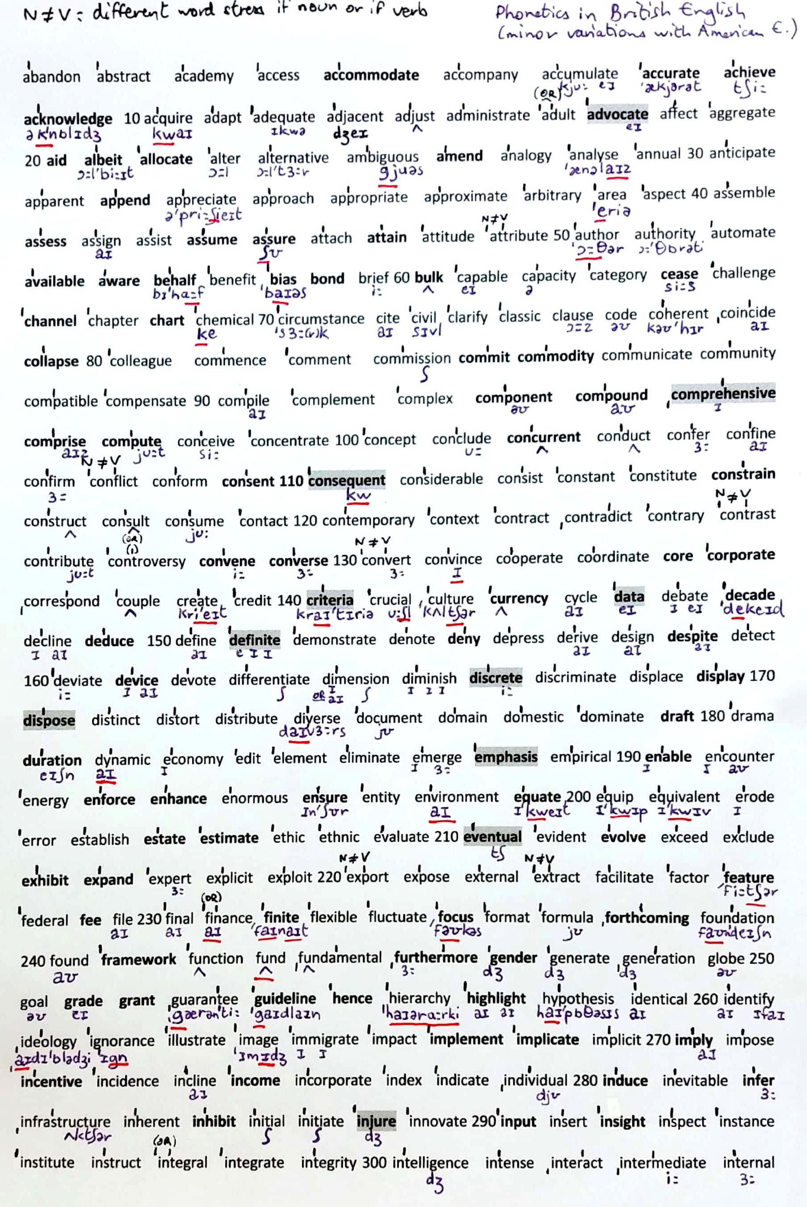
CODE FOR THE LEFT COLUMN:
Transparent words: normal
Not transparent: bold
Not transparent and potentially confusing: bold and red
Confusing or different spelling: in green

Headwords  & link to definition* | Translation if the word is not transparent
abandon | abandonner (verb)
abstract
academy
access
accommodate | loger, recevoir qqn
accompany
accumulate
accurate | précis et exact
achieve | accomplir / parvenir à (un but)
acknowledge | reconnaître (not « admit »)
acquire
adapt
adequate
adjacent
adjust
administrate
adult
advocate | recommander (v) / un défenseur (n)
affect
aggregate
aid
albeit | quoique
allocate | allouer
alter
alternative
ambiguous
amend | amender, corriger
analogy
analyse
annual
anticipate
apparent
append | ajouter
appreciate
approach
appropriate
approximate
arbitrary
area | zone, superficie / domaine
aspect
assemble
assess | évaluer, estimer
assign
assist
assume | présumer, supposer
assure
attach
attain | parvenir à, atteindre
attitude
attribute
author
authority
automate | automatiser
available | disponible
aware | conscient, averti, informé
behalf | (on) behalf (of) : de la part de, aun nom de
benefit | bénéfice, avantage / bénéficier à
bias | préjugé, parti pris
bond | lien, se lier à
brief
bulk | masse, (achat en) gros
capable
capacity
category
cease | cesser de
challenge | défi / défier
channel | canal ; chaîne de tv
chapter
chart | graphique, tableau
chemical | produit chimique
circumstance
cite
civil
clarify
classic
clause
code
coherent
coincide
collapse | s’effondrer
colleague
commence
comment
commission
commit | s’engager à / commettre ( un crime)
commodity | denrée, marchandise
communicate
community
compatible
compensate
compile
complement
complex
component | composant
compound | composé (adj) / mélange, combinaison
comprehensive | exhaustif, complet, global
comprise | englober, comprendre
compute | calculer
conceive
concentrate
concept
conclude
concurrent | simultané, concomitant
conduct
confer
confine
confirm
conflict
conform
consent | consentement / consentir à
consequent | consécutif, qui résulte de
considerable
consist
constant
constitute
constrain | contraindre
construct
consult
consume
contact
contemporary
context
contract
contradict
contrary
contrast
contribute
controversy
convene | convoquer, organiser (une réunion)
converse | contraire, opposé (adj) / converser, discuter
convert
convince
cooperate
coordinate
core | noyau, coeur
corporate | d’entreprise (société)
correspond
couple | couple / deux
create
credit | un crédit / le mérite
criteria | ( ! pluriel de criterion)
crucial
culture
currency | devise, monnaie
cycle
data | données (pluriel)
debate
decade | décennie
decline
deduce
define
definite | défini, précis / certain, définitif
demonstrate
denote
deny | nier, refuser
depress
derive
design | design / motif // concevoir
despite | malgré (+ noun)
detect
deviate
device | appareil (électronique), équipement
devote | dédier, consacrer
differentiate
dimension
diminish
discrete | distinct, séparé
discriminate
displace
display | afficher, exposer
dispose | disposer // dispose of = jeter, se débarrasser de
distinct
distort | fausser, déformer
distribute
diverse
document
domain
domestic
dominate
draft | ébauche, brouillon
drama | théâtre // (faire) une scène, un drame
duration | durée
dynamic
economy
edit
element
eliminate
emerge
emphasis | accent (ex : mettre l’accent sur)
empirical
enable | donner à qqn la possibilité ou le moyen de
encounter | rencontrer , croiser
energy
enforce | imposer, faire respecter (une loi)
enhance | améliorer, augmenter
enormous
ensure | s’assurer que
entity
environment
equate | equivaloir à / assimiler à
equip
equivalent
erode
error
establish
estate | domaine, propriété / biens, fortune
estimate
ethic
ethnic
evaluate
eventual | ultime, final
evident
evolve
exceed
exclude
exhibit | exposer (ex : dans un musée)
expand | étendre
expert
explicit
exploit
export
expose | (s’) exposer (à)
external
extract | extrait / extraire
facilitate | faciliter / animer (une réunion, un débat)
factor
feature | caractéristique (n) / figurer (v)
federal
fee | frais, honoraires
file | dossier, fichier
final
finance
finite | (nombre) fini, limité
flexible
fluctuate
focus | se concentrer sur (focus on)
format
formula
forthcoming | a venir, à paraître
found | fonder
foundation
framework | cadre, structure
function
fund | financer / un fond
fundamental
furthermore | par ailleurs, en outre
gender | genre (sex or identity)
generate
generation
globe
goal
grade | note/classe
grant | accorder (v)/ une bourse (n)
guarantee
guideline | directive/ conseils
hence | d’où (conséquence)
hierarchy
highlight | mettre en lumière
hypothesis
identical
identify
ideology
ignorant
illustrate
image
immigrate
impact
implement | mettre en œuvre, en pratique
implicate | impliquer (dans)
implicit
imply | laisser entendre, insinuer
impose
incentive | incitation, motivation
incidence | fréquence, taux / cas
incline | inclinaison / inciter à, pousser à
income | revenu
incorporate
index
indicate
individual
induce | induire / déclencher, provoquer
inevitable
infer
infrastructure
inherent
inhibit | inhiber
initial
initiate | initier, amorcer
injure | blesser, offenser
innovate
input | contribution, apport
insert
insight | aperçu/ perspicacité
inspect
instance | exemple, cas
institute
instruct
integral
integrate
integrity
intelligent
intense
interact
intermediate
internal
 | end of awl headwords part 1

