VOCABULARY WORK:
The Academic Word List

Section A: headwords of the AWL list - edited version to facilitate learning

- On your smartphone, you can use the AWL builder application to hear the pronunciation of words and read a definition of each word:
https://play.google.com/store/apps/details?id=com.CB.AWLBuilder_global

- On your computer, you can also look at the table further below (semester 2) and click on the words underlined in blue in the first column to access the definition and pronunciation directly online.

- On Moodle, you have links to Quizlet lists to review with flashcards and interactive activities.

* The list on the next 2 pages has been edited to help you learn more efficiently *
- Words which are highlighted are “faux-amis” or have irregular plurals
- Words in bold are probably new to you.
You should still read ALL words and make sure you know the ones which are not in bold as well.

* The list on the following 2 pages has been edited to help you work on pronunciation *
- Indications to help with pronunciation have been added below some words.
(If you are not familiar with phonetic transcription, read the lessons on pronunciation on the Moodle group Ressources apprentissage d’anglais)
- You also have a recorded version of the full list online – listen to it to help memorize the correct pronunciation!

STUDY PROGRAM:
L2 B1 & B2 S2: AWL headwords full list

* Remember that LEARNING a word means learning
its SPELLING and PRONUNCIATION in addition to its meaning!

abandon abstract academy access accommodate accompany accumulate accurate achieve acknowledge 10 acquire adapt adequate adjacent adjust administrate adult advocate affect aggregate 20 aid albeit allocate alter alternative ambiguous amend analogy analyse annual 30 anticipate apparent append appreciate approach appropriate approximate arbitrary area aspect 40 assemble assess assign assist assume assure attach attain attitude attribute 50 author authority automate available aware behalf benefit bias bond brief 60 bulk capable capacity category cease challenge channel chapter chart chemical 70 circumstance cite civil clarify classic clause code coherent coincide collapse 80 colleague commence comment commission commit commodity communicate community compatible compensate 90 compile complement complex component compound comprehensive comprise compute conceive concentrate 100 concept conclude concurrent conduct confer confine confirm conflict conform consent 110 consequent considerable consist constant constitute constrain construct consult consume contact 120 contemporary context contract contradict contrary contrast contribute controversy convene converse 130 convert convince cooperate coordinate core corporate correspond couple create credit 140 criteria crucial culture currency cycle data debate decade decline deduce 150 define definite demonstrate denote deny depress derive design despite detect 160 deviate device devote differentiate dimension diminish discrete discriminate displace display 170 dispose distinct distort distribute diverse document domain domestic dominate draft 180 drama duration dynamic economy edit element eliminate emerge emphasis empirical 190 enable encounter energy enforce enhance enormous ensure entity environment equate 200 equip equivalent erode error establish estate estimate ethic ethnic evaluate 210 eventual evident evolve exceed exclude exhibit expand expert explicit exploit 220 export expose external extract facilitate factor feature federal fee file 230 final finance finite flexible fluctuate focus format formula forthcoming foundation 240 found framework function fund fundamental furthermore gender generate generation globe 250 goal grade grant guarantee guideline hence hierarchy highlight hypothesis identical 260 identify ideology ignorance illustrate image immigrate impact implement implicate implicit 270 imply impose incentive incidence incline income incorporate index indicate individual 280 induce inevitable infer infrastructure inherent inhibit initial initiate injure innovate 290 input insert insight inspect instance institute instruct integral integrate integrity 300 intelligence intense interact intermediate internal interpret interval intervene intrinsic invest 310 investigate invoke involve isolate issue item job journal justify label 320 labour layer lecture legal legislate levy liberal licence likewise link 330 locate logic maintain major manipulate manual margin mature maximise mechanism 340 media mediate medical medium mental method migrate military minimal minimise 350 minimum ministry minor mode modify monitor motive mutual negate network 360 neutral nevertheless nonetheless norm normal notion notwithstanding nuclear objective obtain 370 obvious occupy occur odd offset ongoing option orient outcome output 380 overall overlap overseas panel paradigm paragraph parallel parameter participate partner 390 passive perceive percent period persist perspective phase phenomenon philosophy physical 400 plus policy portion pose positive potential practitioner precede precise predict 410 predominant preliminary presume previous primary prime principal principle prior priority 420 proceed process professional prohibit project promote proportion prospect protocol psychology 430 publication publish purchase pursue qualitative quote radical random range ratio 440 rational react recover refine regime region register regulate reinforce reject 450 relax release relevant reluctance rely remove require research reside resolve 460 resource respond restore restrain restrict retain reveal revenue reverse revise 470 revolution rigid role route scenario schedule scheme scope section sector 480 secure seek select sequence series sex shift significant similar simulate 490 site so-called sole somewhat source specific specify sphere stable statistic 500 status straightforward strategy stress structure style submit subordinate subsequent subsidy 510 substitute successor sufficient sum summary supplement survey survive suspend sustain 520 symbol tape target task team technical technique technology temporary tense 530 terminate text theme theory thereby thesis topic trace tradition transfer 540 transform transit transmit transport trend trigger ultimate undergo underlie undertake 550 uniform unify unique utilise valid vary vehicle version via violate 560 virtual visible vision visual volume voluntary welfare whereas whereby widespread

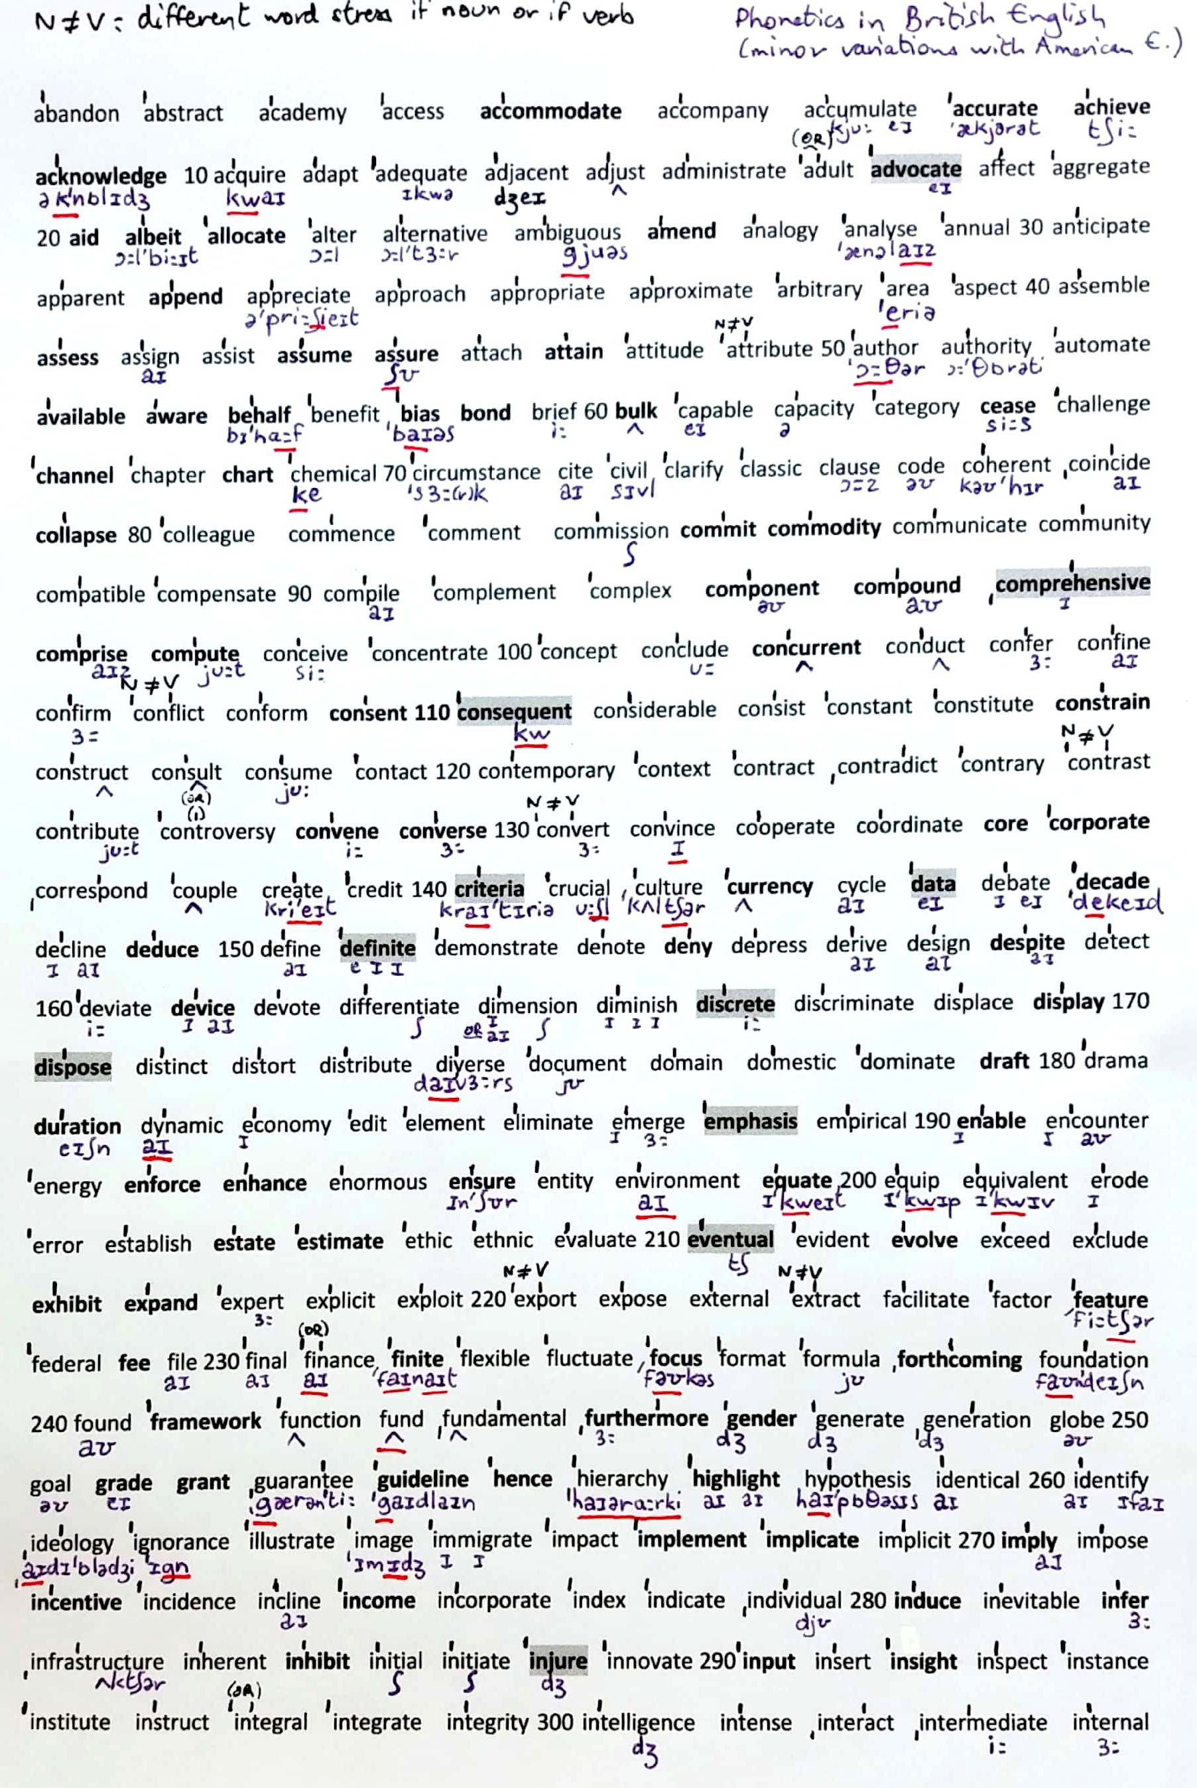
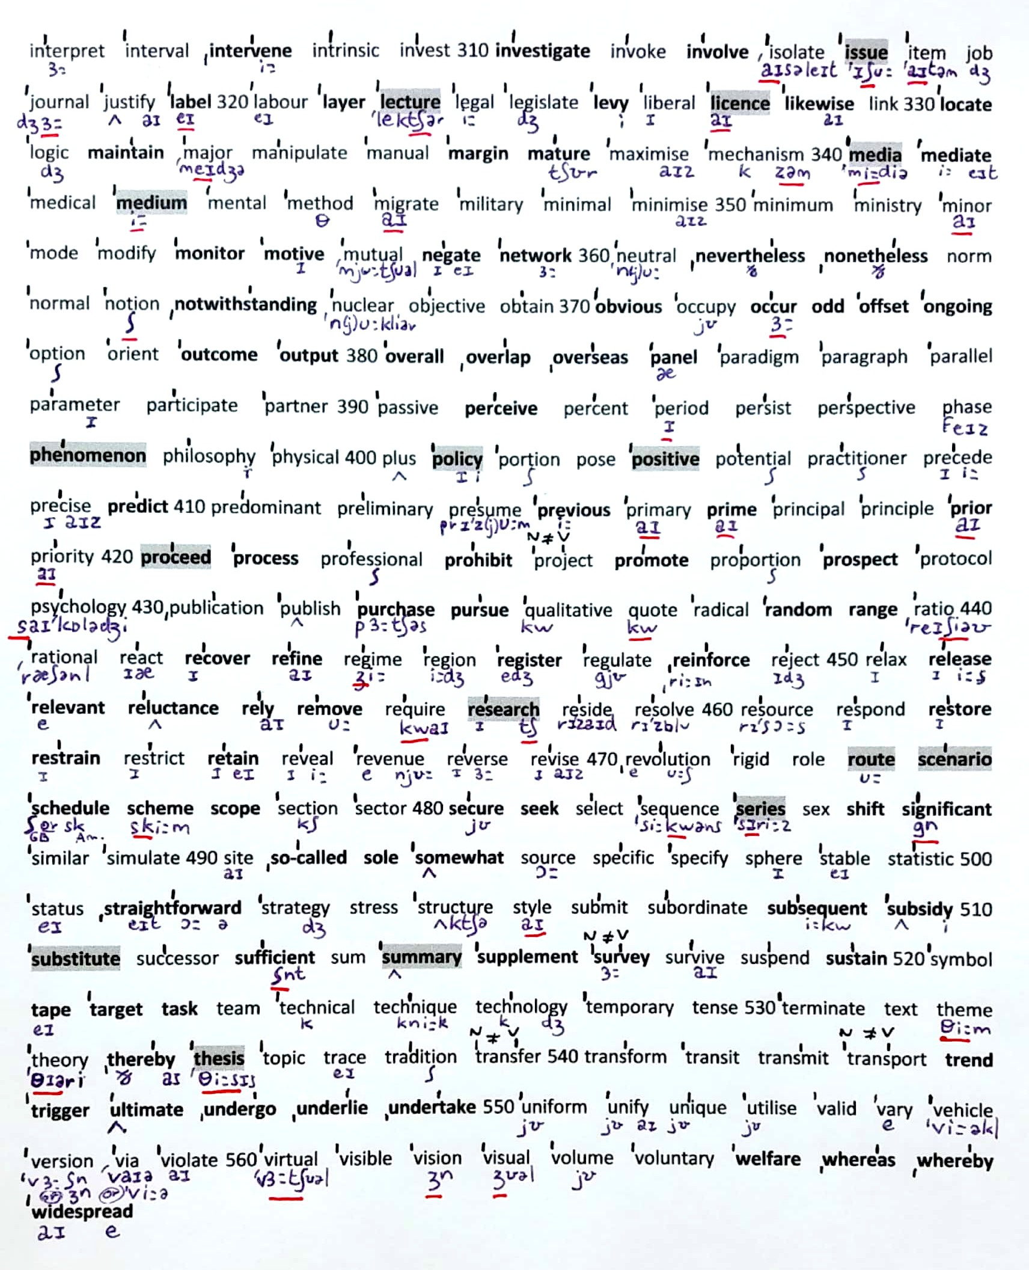

CODE FOR THE LEFT COLUMN:
Transparent words: normal
Not transparent: bold
Not transparent and potentially confusing: bold and red
Confusing or different spelling: in green

Headwords  & link to definition* | Translation if the word is not transparent
abandon | abandonner (verb)
abstract
academy
access
accommodate | loger, recevoir qqn
accompany
accumulate
accurate | précis et exact
achieve | accomplir / parvenir à (un but)
acknowledge | reconnaître (not « admit »)
acquire
adapt
adequate
adjacent
adjust
administrate
adult
advocate | recommander (v) / un défenseur (n)
affect
aggregate
aid
albeit | quoique
allocate | allouer
alter
alternative
ambiguous
amend | amender, corriger
analogy
analyse
annual
anticipate
apparent
append | ajouter
appreciate
approach
appropriate
approximate
arbitrary
area | zone, superficie / domaine
aspect
assemble
assess | évaluer, estimer
assign
assist
assume | présumer, supposer
assure
attach
attain | parvenir à, atteindre
attitude
attribute
author
authority
automate | automatiser
available | disponible
aware | conscient, averti, informé
behalf | (on) behalf (of) : de la part de, aun nom de
benefit | bénéfice, avantage / bénéficier à
bias | préjugé, parti pris
bond | lien, se lier à
brief
bulk | masse, (achat en) gros
capable
capacity
category
cease | cesser de
challenge | défi / défier
channel | canal ; chaîne de tv
chapter
chart | graphique, tableau
chemical | produit chimique
circumstance
cite
civil
clarify
classic
clause
code
coherent
coincide
collapse | s’effondrer
colleague
commence
comment
commission
commit | s’engager à / commettre ( un crime)
commodity | denrée, marchandise
communicate
community
compatible
compensate
compile
complement
complex
component | composant
compound | composé (adj) / mélange, combinaison
comprehensive | exhaustif, complet, global
comprise | englober, comprendre
compute | calculer
conceive
concentrate
concept
conclude
concurrent | simultané, concomitant
conduct
confer
confine
confirm
conflict
conform
consent | consentement / consentir à
consequent | consécutif, qui résulte de
considerable
consist
constant
constitute
constrain | contraindre
construct
consult
consume
contact
contemporary
context
contract
contradict
contrary
contrast
contribute
controversy
convene | convoquer, organiser (une réunion)
converse | contraire, opposé (adj) / converser, discuter
convert
convince
cooperate
coordinate
core | noyau, coeur
corporate | d’entreprise (société)
correspond
couple | couple / deux
create
credit | un crédit / le mérite
criteria | ( ! pluriel de criterion)
crucial
culture
currency | devise, monnaie
cycle
data | données (pluriel)
debate
decade | décennie
decline
deduce
define
definite | défini, précis / certain, définitif
demonstrate
denote
deny | nier, refuser
depress
derive
design | design / motif // concevoir
despite | malgré (+ noun)
detect
deviate
device | appareil (électronique), équipement
devote | dédier, consacrer
differentiate
dimension
diminish
discrete | distinct, séparé
discriminate
displace
display | afficher, exposer
dispose | disposer // dispose of = jeter, se débarrasser de
distinct
distort | fausser, déformer
distribute
diverse
document
domain
domestic
dominate
draft | ébauche, brouillon
drama | théâtre // (faire) une scène, un drame
duration | durée
dynamic
economy
edit
element
eliminate
emerge
emphasis | accent (ex : mettre l’accent sur)
empirical
enable | donner à qqn la possibilité ou le moyen de
encounter | rencontrer , croiser
energy
enforce | imposer, faire respecter (une loi)
enhance | améliorer, augmenter
enormous
ensure | s’assurer que
entity
environment
equate | equivaloir à / assimiler à
equip
equivalent
erode
error
establish
estate | domaine, propriété / biens, fortune
estimate
ethic
ethnic
evaluate
eventual | ultime, final
evident
evolve
exceed
exclude
exhibit | exposer (ex : dans un musée)
expand | étendre
expert
explicit
exploit
export
expose | (s’) exposer (à)
external
extract | extrait / extraire
facilitate | faciliter / animer (une réunion, un débat)
factor
feature | caractéristique (n) / figurer (v)
federal
fee | frais, honoraires
file | dossier, fichier
final
finance
finite | (nombre) fini, limité
flexible
fluctuate
focus | se concentrer sur (focus on)
format
formula
forthcoming | a venir, à paraître
found | fonder
foundation
framework | cadre, structure
function
fund | financer / un fond
fundamental
furthermore | par ailleurs, en outre
gender | genre (sex or identity)
generate
generation
globe
goal
grade | note/classe
grant | accorder (v)/ une bourse (n)
guarantee
guideline | directive/ conseils
hence | d’où (conséquence)
hierarchy
highlight | mettre en lumière
hypothesis
identical
identify
ideology
ignorant
illustrate
image
immigrate
impact
implement | mettre en œuvre, en pratique
implicate | impliquer (dans)
implicit
imply | laisser entendre, insinuer
impose
incentive | incitation, motivation
incidence | fréquence, taux / cas
incline | inclinaison / inciter à, pousser à
income | revenu
incorporate
index
indicate
individual
induce | induire / déclencher, provoquer
inevitable
infer
infrastructure
inherent
inhibit | inhiber
initial
initiate | initier, amorcer
injure | blesser, offenser
innovate
input | contribution, apport
insert
insight | aperçu/ perspicacité
inspect
instance | exemple, cas
institute
instruct
integral
integrate
integrity
intelligent
intense
interact
intermediate
internal

interpret
interval
intervene
intrinsic
invest | investir
investigate | enquêter, investiguer
invoke
involve | impliquer / exiger
isolate
issue | problème, question / parution, sortie
item
job
journal | revue, journal scientifique, livre de bord (// newspaper !)
justify
label | etiquette / étiqueter, cataloguer
labour
layer | couche
lecture | conférence, cours magistral
legal
legislate | légiférer
levy | (pré)lever un impôt
liberal
licence | permis, autorisation
likewise | de même
link | lien / lier
locate | localsier, situer
logic
maintain | entretenir / maintenir
major
manipulate
manual
margin | marge
mature | mûr
maximise
mechanism
media | ! jamais de –s (media est déjà le pluriel de medium)
mediate | arbitrer, servir d’intermédiaire
medical
medium | milieu / moyen
mental
method
migrate
military
minimal
minimise
minimum
ministry
minor
mode
modify
monitor | surveiller, contrôler
motive
mutual
negate
network | réseau
neutral
nevertheless | néanmoins
nonetheless | néanmoins
norm
normal
notion
notwithstanding | en dépit de / bien que
nuclear
objective
obtain
obvious | évident
occupy
occur | arriver, se produire
odd | étrange/ impair (nombre)
offset | compenser, contrebalancer
ongoing | en cours (processus), actuel
option
orient
outcome | résultat, dénouement
output | production, rendement (industrie)
overall | global, d’ensemble
overlap | se chevaucher
overseas | à l’étranger (not « abroad »)
panel | comité, jury
paradigm
paragraph
parallel
parameter
participate
partner
passive
perceive
percent
period
persist
perspective
phase
phenomenon | au singulier => pluriel phenomena
philosophy
physical
plus
policy | politique, règle
portion
pose
positive
potential
practitioner | praticien, médecin
precede
precise
predict
predominant
preliminary
presume
previous | précédent
primary
prime | primordial, principal
principal
principle
prior | précédent, antérieur
priority
proceed | continuer, avancer / procéder, agir
process | processus
professional
prohibit | interdire
project
promote | promouvoir
proportion
prospect | perspective (d’avenir)
protocol
psychology
publication
publish | publier
purchase | achat
pursue | poursuivre
qualitative
quote | citer
radical
random | aléatoire (au hasard)
range | gamme, registre, variation / portée
ratio
rational
react
recover | récupérer, se rétablir
refine | affiner / raffiner
regime | (politique)
region
register | s’inscrire (par ex : à un cours)
regulate
reinforce
reject
relax
release | publier / parution, sortie
relevant | pertinent
reluctance | réticence
rely | compter (sur), reposer (sur)
remove | enlever
require
research
reside
resolve | résoudre, décider
resource
respond
restore
restrain | retenir, contenir qqn
restrict | restreindre, limiter
retain | conserver, garder
reveal
revenue | revenu, recettes
reverse | inverser / contraire
revise
revolution
rigid
role
route | itinéraire
scenario
schedule | programme, planning
scheme | plan, projet / machination
scope | portée, étendue, ampleur
section
sector
secure | sûr, sécurisant / assurer, garantir
seek | chercher
select
sequence
series | toujours avec un –s même au singulier
sex
shift | modifier (v)/ un changement (n)
significant | significatif
similar
simulate
site
so-called | soi-disant
sole | seul, unique
somewhat | quelque peu
source
specific
specify
sphere
stable
statistic
status
straightforward | direct, facile/ franc, honnête
strategy
stress | stress, pression / accent, insistance
structure
style
submit
subordinate
subsequent | suivant, ultérieur
subsidy | subvention
substitute | substituer / remplaçant
successor
sufficient
sum
summary | résumé
supplement
survey | enquête, sondage
survive
suspend
sustain | soutenir / supporter / subir
symbol
tape | ruban / enregistrement
target | cible
task | tâche
team
technical
technique
technology
temporary
tense | tendu / temps (grammatical)
terminate | terminer, mettre fin à
text
theme
theory
thereby | de cette façon, par là
thesis | singulier => pluriel theses
topic | sujet, thème
trace
tradition
transfer
transform
transit
transmit
transport
trend | tendance, phénomène
trigger | déclencher, provoquer
ultimate | ultime, final
undergo | subir (ex :une opération)
underlie | sous-tendre, être à la base de
undertake | entreprendre
uniform
unify
unique
utilise
valid
vary
vehicle
version
via
violate
virtual
visible
vision
visual
volume
voluntary
welfare | bien-être/aide sociale
whereas | alors que, bien que
whereby | au moyen duquel, par lequel
widespread | très répandu, courant

