VOCABULARY WORK:
The Academic Word List

Section A: headwords of the AWL list - edited version to facilitate learning

- On your smartphone, you can use the AWL builder application to hear the pronunciation of words and read a definition of each word:
https://play.google.com/store/apps/details?id=com.CB.AWLBuilder_global

- On your computer, you can also look at the table further below (semester 2) and click on the words underlined in blue in the first column to access the definition and pronunciation directly online.

- On Moodle, you have links to Quizlet lists to review with flashcards and interactive activities.

* The list on the next 2 pages has been edited to help you learn more efficiently *
- Words which are highlighted are “faux-amis” or have irregular plurals
- Words in bold are probably new to you.
You should still read ALL words and make sure you know the ones which are not in bold as well.

* The list on the following 2 pages has been edited to help you work on pronunciation *
- Indications to help with pronunciation have been added below some words.
(If you are not familiar with phonetic transcription, read the lessons on pronunciation on the Moodle group Ressources apprentissage d’anglais)
- You also have a recorded version of the full list online – listen to it to help memorize the correct pronunciation!

STUDY PROGRAM:
L2 B1 & B2 S2: AWL headwords full list

* Remember that LEARNING a word means learning
its SPELLING and PRONUNCIATION in addition to its meaning!

abandon abstract academy access accommodate accompany accumulate accurate achieve acknowledge 10 acquire adapt adequate adjacent adjust administrate adult advocate affect aggregate 20 aid albeit allocate alter alternative ambiguous amend analogy analyse annual 30 anticipate apparent append appreciate approach appropriate approximate arbitrary area aspect 40 assemble assess assign assist assume assure attach attain attitude attribute 50 author authority automate available aware behalf benefit bias bond brief 60 bulk capable capacity category cease challenge channel chapter chart chemical 70 circumstance cite civil clarify classic clause code coherent coincide collapse 80 colleague commence comment commission commit commodity communicate community compatible compensate 90 compile complement complex component compound comprehensive comprise compute conceive concentrate 100 concept conclude concurrent conduct confer confine confirm conflict conform consent 110 consequent considerable consist constant constitute constrain construct consult consume contact 120 contemporary context contract contradict contrary contrast contribute controversy convene converse 130 convert convince cooperate coordinate core corporate correspond couple create credit 140 criteria crucial culture currency cycle data debate decade decline deduce 150 define definite demonstrate denote deny depress derive design despite detect 160 deviate device devote differentiate dimension diminish discrete discriminate displace display 170 dispose distinct distort distribute diverse document domain domestic dominate draft 180 drama duration dynamic economy edit element eliminate emerge emphasis empirical 190 enable encounter energy enforce enhance enormous ensure entity environment equate 200 equip equivalent erode error establish estate estimate ethic ethnic evaluate 210 eventual evident evolve exceed exclude exhibit expand expert explicit exploit 220 export expose external extract facilitate factor feature federal fee file 230 final finance finite flexible fluctuate focus format formula forthcoming foundation 240 found framework function fund fundamental furthermore gender generate generation globe 250 goal grade grant guarantee guideline hence hierarchy highlight hypothesis identical 260 identify ideology ignorance illustrate image immigrate impact implement implicate implicit 270 imply impose incentive incidence incline income incorporate index indicate individual 280 induce inevitable infer infrastructure inherent inhibit initial initiate injure innovate 290 input insert insight inspect instance institute instruct integral integrate integrity 300 intelligence intense interact intermediate internal interpret interval intervene intrinsic invest 310 investigate invoke involve isolate issue item job journal justify label 320 labour layer lecture legal legislate levy liberal licence likewise link 330 locate logic maintain major manipulate manual margin mature maximise mechanism 340 media mediate medical medium mental method migrate military minimal minimise 350 minimum ministry minor mode modify monitor motive mutual negate network 360 neutral nevertheless nonetheless norm normal notion notwithstanding nuclear objective obtain 370 obvious occupy occur odd offset ongoing option orient outcome output 380 overall overlap overseas panel paradigm paragraph parallel parameter participate partner 390 passive perceive percent period persist perspective phase phenomenon philosophy physical 400 plus policy portion pose positive potential practitioner precede precise predict 410 predominant preliminary presume previous primary prime principal principle prior priority 420 proceed process professional prohibit project promote proportion prospect protocol psychology 430 publication publish purchase pursue qualitative quote radical random range ratio 440 rational react recover refine regime region register regulate reinforce reject 450 relax release relevant reluctance rely remove require research reside resolve 460 resource respond restore restrain restrict retain reveal revenue reverse revise 470 revolution rigid role route scenario schedule scheme scope section sector 480 secure seek select sequence series sex shift significant similar simulate 490 site so-called sole somewhat source specific specify sphere stable statistic 500 status straightforward strategy stress structure style submit subordinate subsequent subsidy 510 substitute successor sufficient sum summary supplement survey survive suspend sustain 520 symbol tape target task team technical technique technology temporary tense 530 terminate text theme theory thereby thesis topic trace tradition transfer 540 transform transit transmit transport trend trigger ultimate undergo underlie undertake 550 uniform unify unique utilise valid vary vehicle version via violate 560 virtual visible vision visual volume voluntary welfare whereas whereby widespread

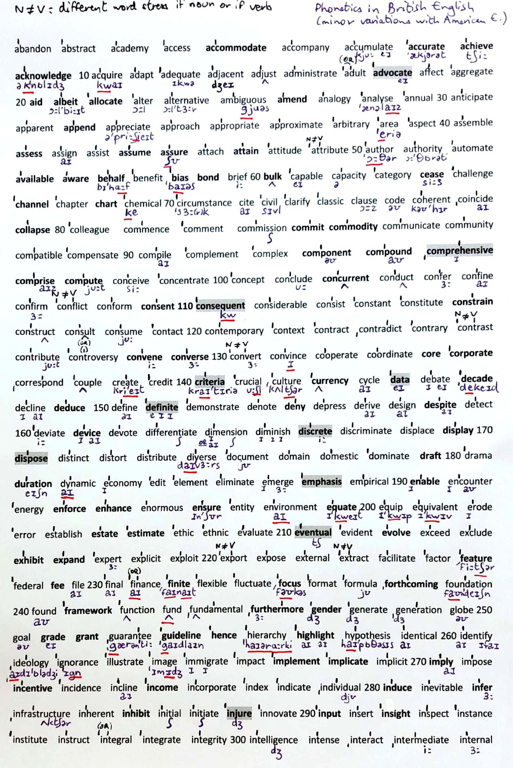
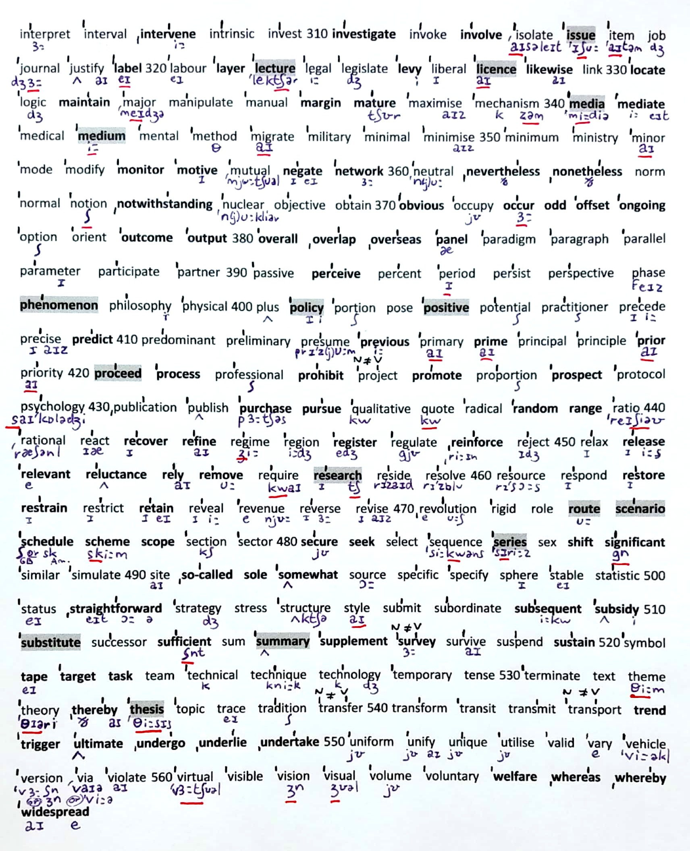

COLOR CODE:
Transparent words: normal
Not transparent: bold
Not transparent and potentially confusing: bold and red
Confusing or different spelling: in green

Headwords  & link to definition* | Translation if the word is not transparent | Subwords - derived words
abandon | abandonner (verb) | abandonment  abandon (n.)
abstract |  | abstraction, abstractly
academy |  | academia, academic, academically, academics  le monde universitaire
access |  | accessibility, accessible, inaccessible
accommodate | loger, recevoir qqn | accommodation  logement
accompany |  | accompaniment, unaccompanied
accumulate |  | accumulation
accurate | précis et exact | accuracy, accurately, inaccuracy, inaccurate  exactitude, exactement, inexactitude, inexact
achieve | accomplir / parvenir à (un but) | achievable, achievement  atteignable, réussite
acknowledge | reconnaître (not « admit ») | acknowledgement  reconnaissance
acquire |  | acquisition
adapt |  | adaptability, adaptable, adaptation, adaptive
adequate |  | adequacy, adequately, inadequacy, inadequate, inadequately  adéquation, de manière adéquate, inadéquation, etc
adjacent
adjust |  | adjustment, readjust, readjustment
administrate |  | administration, administrative, administratively, administrator
adult |  | adulthood
advocate | recommander (v) / un défenseur (n) | advocacy  plaidoyer
affect |  | affective, affectively, unaffected
aggregate |  | aggregation
aid |  | unaided
albeit | quoique
allocate | allouer | allocation
alter |  | alterable, alteration, alternate, alternating, unalterable, unaltered  inalterable, inaltéré
alternative |  | alternatively
ambiguous |  | ambiguity, unambiguous, unambiguously  non ambigu, sans ambiguité
amend | amender, corriger | amendment
analogy |  | analogous
analyse |  | analyser, analyses, analysis, analyst, analytic, analytical, analytically
annual |  | annually
anticipate |  | anticipation, unanticipated  non anticipé
apparent |  | apparently
append | ajouter | appendix, appendices, appendixes
appreciate |  | appreciable, appreciably, appreciation, unappreciated  méconnu ou incompris
approach |  | approachable, unapproachable  inabordable
appropriate |  | appropriacy, appropriately, appropriateness, inappropriacy, inappropriate, inappropriately
approximate |  | approximately, approximation
arbitrary |  | arbitrariness, arbitrarily  aspect arbitraire, arbitrairement
area | zone, superficie / domaine
aspect
assemble |  | assembly
assess | évaluer, estimer | assessable, assessment, reassess, reassessment, unassessed  évaluable, évaluation, réévaluer, réévaluation, non évalué
assign |  | assignment, reassign, unassigned  devoir, réattribuer, non attribué
assist |  | assistance, assistant, unassisted  sans assistance
assume | présumer, supposer | assumption  supposition
assure |  | assurance, assuredly
attach |  | attachment, unattached  attachement/fichier joint ; non attaché, libre
attain | parvenir à, atteindre | attainable, attainment, unattainable  atteignable, realisation, inatteignable
attitude
attribute |  | attributable, attribution
author |  | authorship  paternité (d’une œuvre)
authority |  | authoritative  faisant autorité
automate | automatiser | automatic, automatically, automation
available | disponible | availability, unavailable  disponibilité, indisponible
aware | conscient, averti, informé | awareness, unaware  conscience, non conscient de
behalf | (on) behalf (of) : de la part de, au nom de
benefit | bénéfice, avantage / bénéficier à | beneficial, beneficiary  bénéfique, bénéficiaire
bias | préjugé, parti pris | unbiased  non biaisé, objectif
bond | lien, se lier à
brief |  | brevity, briefly  brièveté, brièvement
bulk | masse, (achat en) gros | bulky  volumineux
capable |  | capability, incapable  aptitude
capacity |  | incapacitate  handicaper
category |  | categorisation, categorise, categorizing
cease | cesser de | ceaseless  incessant
challenge | défi / défier | challenger  adversaire
channel | canal ; chaîne de tv
chapter
chart | graphique, tableau | uncharted  inexploré
chemical | produit chimique | chemically, chemicals  chimiquement, produits chimiques
circumstance
cite |  | citation
civil
clarify |  | clarification, clarity  …, clarté
classic |  | classical, classics
clause
code
coherent |  | coherence, coherently, incoherent, incoherently  de manière cohérente
coincide |  | coincidence, coincident, coincidental  fortuit
collapse | s’effondrer | collapsible  pliant
colleague
commence |  | commencement, recommence  remise des diplômes
comment |  | commentary, commentator
commission |  | commissioner
commit | s’engager à / commettre (un crime) | commitment  engagement
commodity | denrée, marchandise
communicate |  | communicable, communication, communicative, communicatively, uncommunicative
community
compatible |  | compatibility, incompatibility, incompatible
compensate |  | compensation, compensatory
compile |  | compilation
complement |  | complementary
complex |  | complexity
component | composant | componentry
compound | composé (adj) / mélange, combinaison
comprehensive | exhaustif, complet, global | comprehensively  complètement
comprise | englober, comprendre
compute | calculer | computation, computational, computable, computer, computerised
conceive |  | conceivable, conceivably, inconceivable, inconceivably
concentrate |  | concentration
concept |  | conception, conceptual, conceptualisation, conceptualise, conceptually
conclude |  | conclusion, conclusive, conclusively, inconclusive, inconclusively  …, concluant, de façon concluante, peu concluant, etc.
concurrent | simultané, concomitant | concurrently  simultanément
conduct
confer |  | conference
confine |  | unconfined
confirm |  | confirmation
conflict
conform |  | conformable, conformability, conformance, conformation, conformist, conformity, non-conformist, non-conformity
consent | consentement / consentir à | consensus
consequent | consécutif, qui résulte de | consequence, consequently  par conséquent
considerable |  | considerably
consist |  | consistency, consistent, consistently, inconsistency, inconsistent  cohérence, cohérent, etc.
constant |  | constancy, constantly, inconstancy, inconstantly
constitute |  | constituency, constituent, constitution, constitutional, constitutionally, constitutive, unconstitutional  électeurs (de la circonscription), électeur
constrain | contraindre | constraint, unconstrained  contrainte, non contraint
construct |  | construction, constructive, reconstruct, reconstruction
consult |  | consultancy, consultant, consultation, consultative
consume |  | consumer, consumption  consommateur, consommation
contact |  | contactable
contemporary
context |  | contextual, contextualise, uncontextualised
contract |  | contractor
contradict |  | contradiction, contradictory
contrary |  | contrarily
contrast |  | contrastive
contribute |  | contribution, contributor
controversy |  | controversial, controversially, uncontroversial
convene | convoquer, organiser (une réunion) | convention, conventional, conventionally, unconventional
converse | contraire, opposé (adj) / converser, discuter | conversely  inversement
convert |  | conversion, convertible
convince |  | convincingly, unconvinced  de manière convaincante, non convaincu
cooperate |  | cooperation, cooperative, cooperatively
coordinate |  | coordination, coordinator
core | noyau, coeur
corporate | d’entreprise (société) | corporation
correspond |  | correspondence, correspondingly
couple | couple / deux
create |  | creation, creative, creatively, creativity, creator, recreate
credit | un crédit / le mérite | creditor
criteria | ( ! pluriel de criterion) | criterion (singulier)
crucial |  | crucially
culture |  | cultural, culturally, uncultured
currency | devise, monnaie
cycle |  | cyclic, cyclical
data | données (pluriel)
debate |  | debatable  discutable ou contestable
decade | décennie
decline
deduce |  | deduction
define |  | definable, definition, redefine, undefined  définissable, …, indéfini
definite | défini, précis / certain, définitif | definitely, definitive, indefinite, indefinitely  de manière définitive, …, indéfini
demonstrate |  | demonstrable, demonstrably, demonstration, demonstrative, demonstratively, demonstrator
denote |  | denotation
deny | nier, refuser | deniable, denial, undeniable  niable, déni, indéniable
depress |  | depression
derive |  | derivation, derivative
design | design / motif // concevoir | designer
despite | malgré (+ noun)
detect |  | detectable, detection, detective, detector
deviate |  | deviation
device | appareil (électronique), équipement
devote | dédier, consacrer | devotedly, devotion
differentiate |  | differentiation
dimension |  | dimensional, multidimensional
diminish |  | diminution, undiminished
discrete | distinct, séparé, individual  (≠discrete: discret) | discretely, discretion, discretionary, indiscrete, indiscretion  distinctement, /discrétion/, discrétionnaire, /indiscret/, /indiscretion/
discriminate |  | discriminating, discrimination
displace |  | displacement  remplacement ou déplacement
display | afficher, exposer
dispose | disposer // dispose of = jeter, se débarrasser de | disposable, disposal  jetable; destruction ou disposition
distinct |  | distinction, distinctive, distinctively, distinctly, indistinct, indistinctly  … , distinct, de manière caractéristique, distinctement, …
distort | fausser, déformer | distortion
distribute |  | distribution, distributional, distributive, distributor, redistribute, redistribution
diverse |  | diversely, diversification, diversify, diversity
document |  | documentation
domain
domestic |  | domestically, domesticate, domestics
dominate |  | dominance, dominant, domination
draft | ébauche, brouillon | redraft
drama | théâtre // (faire) une scène, un drame | dramas, dramatic, dramatically, dramatise, dramatisation, dramatist  …. , spectaculaire, de manière spectaculaire, …
duration | durée
dynamic |  | dynamically, dynamics
economy |  | economic, economical, economically, economics, economist, uneconomical  économique (cf économie), peu cher, …, l’économie, … , peu rentable
edit |  | edition, editor, editorial
element
eliminate |  | elimination
emerge |  | emergence, emergent
emphasis | accent (ex : mettre l’accent sur) | emphasise, emphatic, emphatically  accentuer, catégorique(ment) ou énergique(ment)
empirical |  | empirically, empiricism
enable | donner à qqn la possibilité ou le moyen de
encounter | rencontrer , croiser
energy |  | energetic, energetically  énergique ou énergetique
enforce | imposer, faire respecter (une loi) | enforcement  mise en application
enhance | améliorer, augmenter | enhancement  amélioration
enormous |  | enormity, enormously
ensure | s’assurer que
entity
environment |  | environmental, environmentalist, environmentally
equate | équivaloir à / assimiler à | equation
equip |  | equipment
equivalent |  | equivalence
erode |  | erosion
error |  | erroneous, erroneously
establish |  | disestablish, disestablishment, establishment
estate | domaine, propriété / biens, fortune
estimate | Estimation, devis | estimation, overestimate, underestimate  estime ou jugement, surestimer, sous-estimer
ethic |  | ethical, ethically, ethics, unethical  … , …, l’étique, non éthique
ethnic |  | ethnicity
evaluate |  | evaluation, evaluative, re-evaluate, re-evaluation
eventual | ultime, final | eventuality, eventually  éventualité ; finalement
evident |  | evidence, evidential, evidently  preuves (tjs sing.!), basé sur des preuves, de toute évidence
evolve |  | evolution, evolutionary, evolutionist
exceed
exclude |  | exclusion, exclusionary, exclusionist, exclusive, exclusively
exhibit | exposer (ex : dans un musée) | exhibition, exhibits  exposition; oeuvres exposées
expand | étendre | expansion, expansionism, expansive  …, .., étendu ou expansif
expert |  | expertise, expertly
explicit |  | explicitly
exploit |  | exploitation
export |  | exporter
expose | (s’) exposer (à) | exposure  exposition (photo, lumière) ou révélation (publique)
external |  | externalisation, externality
extract | extrait / extraire | extraction
facilitate | faciliter / animer (une réunion, un débat) | facilities, facilitation, facilitator, facility  installations ou équipements ; … , …, possibilité ou fonction
factor
feature | caractéristique (n) / figurer (v)
federal |  | federation
fee | frais, honoraires
file | dossier, fichier
final |  | finalise, finality, finally, finals  … , caractère definitif, …, examens de fin d’année
finance |  | financial, financially
finite | (nombre) fini, limité | infinite, infinitely
flexible |  | flexibility, inflexible, inflexibility
fluctuate |  | fluctuation
focus | se concentrer sur (focus on) | refocus
format
formula |  | formulae, formulas, formulate, formulation, reformulate, reformulation
forthcoming | a venir, à paraître
found | fonder | founder, unfounded  fondateur; sans fondement ou injustifié
foundation
framework | cadre, structure
function |  | functional, functionally
fund | financer / un fond
fundamental |  | fundamentally
furthermore | par ailleurs, en outre
gender | genre (sex or identity)
generate
generation
globe |  | global, globally, globalisation
goal
grade | note/classe
grant | accorder (v)/ une bourse (n)
guarantee
guideline | directive/ conseils
hence | d’où (conséquence)
hierarchy |  | hierarchical
highlight | mettre en lumière | highlighted
hypothesis |  | hypotheses, hypothesise, hypothetical, hypothetically  (pluriel); conjecturer; hypothétique, en théorie
identical |  | identically
identify |  | identifiable, identification, identity, unidentifiable  non identifiable
ideology |  | ideological, ideologically
ignorant |  | ignorance, ignore
illustrate |  | illustration, illustrative  explicatif ou qui sert à illustrer
image |  | imagery
immigrate |  | immigrant, immigration
impact
implement | mettre en œuvre, en pratique | implementation  mise en œuvre ou exécution
implicate | impliquer (dans) | implication
implicit |  | implicitly
imply | laisser entendre, insinuer
impose |  | imposition  mise en place ou imposition de
incentive | incitation, motivation
incidence | fréquence, taux / cas | incident, incidentally  … ; accidentel ou secondaire
incline | inclinaison / inciter à, pousser à | inclination
income | revenu
incorporate |  | incorporation
index
indicate |  | indication, indicative, indicator
individual |  | individuality, individualism, individualist, individualistic, individually  … , … , (noun) , (adjective), …
induce | induire / déclencher, provoquer | induction  déclenchement ou intégration
inevitable |  | inevitability, inevitably
infer |  | inference
infrastructure
inherent |  | inherently
inhibit | inhiber | inhibition
initial |  | initially
initiate | initier, amorcer | initiation, initiative, initiator  mise en place ou initiation à, … , instigateur
injure | blesser, offenser | injury, uninjured  blessure, indemne
innovate |  | innovation, innovative, innovator
input | contribution, apport
insert |  | insertion
insight | aperçu/ perspicacité | insightful  perspicace
inspect |  | inspection, inspector
instance | exemple, cas
institute |  | institution, institutional, institutionalise, institutionally
instruct |  | instruction, instructive, instructor
integral
integrate |  | integration
integrity
intelligent |  | intelligence, intelligently, unintelligent
intense |  | intensely, intenseness, intensification, intensify, intension, intensity, intensive, intensively
interact |  | interaction, interactive, interactively
intermediate
internal |  | internalise, internally
interpret |  | interpretation, interpretative, interpretive, misinterpret, misinterpretation, reinterpret, reinterpretation  … , explicatif, d’interprétation, mal interprêter, contresens, …
interval
intervene |  | intervention
intrinsic |  | intrinsically  intrinsèquement
invest | investir | investment, investor, reinvest, reinvestment  investissement, investisseur, etc.
investigate | enquêter, investiguer | investigation, investigative, investigator  enquête, d’investigation, investigateur
invoke
involve | impliquer / exiger | involvement, uninvolved  implication, pas impliqué ou détaché
isolate |  | isolation, isolationism
issue | problème, question / parution, sortie
item |  | itemisation, itemise
job
journal | revue, journal scientifique, livre de bord
justify |  | justifiable, justifiably, justification, unjustified  …, à juste titre, …, injustifié
label | etiquette / étiqueter, cataloguer
labour
layer | couche
lecture | conférence, cours magistral | lecturer  conférencier ou maître de conférences
legal |  | illegal, illegality, illegally, legality, legally
legislate | légiférer | legislation, legislative, legislator, legislature
levy | (pré)lever un impôt
liberal |  | liberalise, liberalism, liberalisation, liberate, liberation, liberator, liberally
licence | permis, autorisation | unlicensed  illicite ou non autorisé
likewise | de même
link | lien / lier | linkage
locate | localiser, situer | location, relocate, relocation  emplacement, délocaliser ou déménager, délocalisation ou déménagement
logic |  | illogical, illogically, logical, logically, logician
maintain | entretenir / maintenir | maintenance  maintien ou entretien
major |  | majority
manipulate |  | manipulation, manipulative  …, manipulateur
manual |  | manually
margin | marge | marginal, marginally
mature | mûr | immature, immaturity, maturation, maturational, maturity
maximise |  | maximisation, maximum
mechanism
media | ! jamais de –s (c’est le pluriel de medium)
mediate | arbitrer, servir d’intermédiaire | mediation
medical |  | medically
medium | milieu / moyen
mental |  | mentality, mentally
method |  | methodical, methodological, methodology
migrate |  | migrant, migration, migratory
military
minimal |  | minimalisation, minimalise, minimalist, minimalistic, minimally
minimise
minimum
ministry |  | ministerial
minor |  | minority
mode
modify |  | modification, modifying, unmodified
monitor | surveiller, contrôler | monitoring, unmonitored  surveillance, sans surveillance
motive |  | motivate, motivation, unmotivated  …, …., sans motif
mutual |  | mutually
negate |  | negative, negatively
network | réseau
neutral |  | neutralisation, neutralise, neutrality
nevertheless | néanmoins
nonetheless | néanmoins
norm
normal |  | abnormal, abnormally, normalisation, normalise, normality, normally
notion
notwithstanding | en dépit de / bien que
nuclear
objective |  | objectively, objectivity
obtain |  | obtainable, unobtainable  disponible ou qu’on peut se procurer ; impossible à obtenir
obvious | évident | obviously
occupy |  | occupancy, occupant, occupation, occupational, occupier  occupation, …, profession ou passe-temps, professionnel, occupant
occur | arriver, se produire | occurrence, reoccur  événement ou cas, se reproduire
odd | étrange/ impair (nombre) | odds  chances
offset | compenser, contrebalancer
ongoing | en cours (processus), actuel
option |  | optional
orient |  | orientation, reorient, reorientation
outcome | résultat, dénouement
output | production, rendement (industrie)
overall | global, d’ensemble
overlap | se chevaucher
overseas | à l’étranger
panel | comité, jury
paradigm
paragraph
parallel
parameter
participate |  | participant, participation, participatory
partner |  | partnership  partenariat
passive |  | passively, passivity
perceive |  | perception
percent |  | percentage
period |  | periodic, periodical, periodically, periodicals
persist |  | persistence, persistent, persistently
perspective
phase
phenomenon | au singulier  => pluriel : phenomena | phenomena, phenomenal
philosophy |  | philosopher, philosophical, philosophically, philosophise
physical |  | physically
plus
policy | politique, règle
portion
pose
positive |  | positively  formellement ou positivement
potential |  | potentially
practitioner | praticien, médecin
precede |  | precedence, precedent, preceding, unprecedented  priorité, précédent, précédent, sans précédent
precise |  | imprecise, precisely, precision
predict |  | predictability, predictable, predictably, prediction, unpredictability, unpredictable  prévisibilité, prévisible, … , …, imprévisibilité, imprévisible
predominant |  | predominance, predominantly, predominate
preliminary
presume |  | presumably, presumption, presumptuous  vraisemblablement, supposition, présomptueux
previous | précédent | previously
primary |  | primarily
prime | primordial, principal | primacy  primauté
principal |  | principally
principle |  | unprincipled  peu scrupuleux ou sans scrupules
prior | précédent, antérieur
priority |  | prioritisation, prioritise
proceed | continuer, avancer / procéder, agir | procedural, procedure, proceedings  …, …, réunion ou cérémonie ou débats
process | processus
professional |  | professionally, professionalism
prohibit | interdire | prohibition, prohibitive  interdiction, prohibitif
project |  | projection
promote | promouvoir | promoter, promotion  organisateur ou promoteur ; avancement ou promotion
proportion |  | disproportion, disproportionate, disproportionately, proportional, proportionally, proportionate, proportionately
prospect | perspective (d’avenir) | prospective  potentiel ou futur
protocol
psychology |  | psychological, psychologically, psychologist
publication
publish | publier | publisher, unpublished  éditeur, inédit
purchase | achat | purchaser
pursue | poursuivre | pursuit  recherche ou poursuite
qualitative |  | qualitatively
quote | citer | quotation
radical |  | radically
random | aléatoire (au hasard) | randomly, randomness  au hasard, caractère aléatoire
range | gamme, registre, variation / portée
ratio
rational |  | irrational, rationalisation, rationalise, rationalism, rationality, rationally
react |  | reaction, reactionary, reactive, reactivate, reactivation, reactor
recover | récupérer, se rétablir | recoverable, recovery  récupérable, reprise (éco) ou guérison
refine | affiner / raffiner | refinement
regime | (politique)
region |  | regional, regionally
register | s’inscrire  (par ex : à un cours) | deregister, deregistration, registration  retirer d’une liste, …, inscription
regulate |  | deregulation, regulation, regulator, regulatory, unregulated
reinforce |  | reinforcement
reject |  | rejection
relax |  | relaxation
release | publier / parution, sortie
relevant | pertinent | irrelevance, irrelevant, relevance  manque de pertinence, non pertinent, pertinence
reluctance | réticence | reluctant, reluctantly  réticent, avec réticence ou à contre-coeur
rely | compter (sur), reposer (sur) | reliability, reliable, reliably, reliance, reliant, unreliable  fiabilité, fiable, …, dépendance, dépendant de, peu ou pas fiable
remove | enlever | removable, removal  amovible ou détachable, suppression (ou uk : déménagement)
require |  | requirement  exigence ou condition requise
research |  | researcher, researches
reside |  | residence, resident, residential
resolve | résoudre, décider | resolution, unresolved
resource |  | resourceful, unresourceful, under-resourced  ingénieux, peu ingénieux, qui manque de ressources
respond |  | respondent, response, responsive, responsiveness, unresponsive  sondé, …, réceptif, …, qui ne réagit pas
restore |  | restoration  rétablissement ou restauration
restrain | retenir, contenir qqn | restraint, unrestrained  modération ou limitation ; sans retenue ou sans entraves
restrict | restreindre, limiter | restriction, restrictive, restrictively, unrestricted, unrestrictive
retain | conserver, garder | retainer, retention, retentive
reveal |  | revelation
revenue | revenu, recettes
reverse | inverser / contraire | reversal, reversible, irreversible
revise |  | revision
revolution |  | revolutionary, revolutionise, revolutionist
rigid |  | rigidity, rigidly
role
route | itinéraire
scenario |  | pl: scenarios or scenari
schedule | programme, planning | reschedule, unscheduled  changer l’heure ou la date de ; imprévu
scheme | plan, projet / machination | schematic, schematically
scope | portée, étendue, ampleur
section
sector
secure | sûr, sécurisant / assurer, garantir | insecure, insecurity, securely, security  peu sûr ou angoissé, …., solidement, …
seek | chercher | conj : has sought, sought
select |  | selection, selective, selectively, selector
sequence |  | sequential, sequentially
series | toujours avec un –s même au singulier | (always has an –s even in the singular)
sex |  | sexism, sexual, sexuality, sexually
shift | modifier (v)/ un changement (n)
significant | significatif | insignificant, insignificantly, significance, significantly, signify  insignificant, …, importance, considérablement, …
similar |  | dissimilar, similarity, similarly  différent, …, de façon similaire
simulate |  | simulation
site
so-called | soi-disant
sole | seul, unique | solely
somewhat | quelque peu
source
specific |  | specifically, specification, specificity, specifics  …, précision ou stipulation, … , détails
specify |  | specifiable, unspecified
sphere |  | spherical, spherically
stable |  | instability, stabilisation, stabilise, stability, unstable
statistic |  | statistician, statistical, statistically, statistics
status
straightforward | direct, facile/ franc, honnête
strategy |  | strategic, strategically, strategist
stress | stress, pression / accent, insistance | stressful, unstressed  stressant; inaccentué
structure |  | restructure, structural, structurally, unstructured
style |  | styling, stylish, stylise  …, chic ou élégant, …
submit |  | submission  proposition ou soumission
subordinate |  | subordination
subsequent | suivant, ultérieur | subsequently  par la suite
subsidy | subvention | subsidiary, subsidise  filiale ; subventionner
substitute | substituer / remplaçant | substitution
successor |  | succession, successive, successively
sufficient |  | sufficiency, insufficient, insufficiently, sufficiently  quantité suffisante, insuffisant, insuffisamment, suffisamment
sum |  | summation  addition ou résumé
summary | résumé | summarise, summarisation  résumer, recapitulatif ou synthèse
supplement |  | supplementary  supplémentaire ou complémentaire
survey | enquête, sondage
survive |  | survival, survivor  survie, survivant
suspend |  | suspension
sustain | soutenir / supporter / subir | sustainable, sustainability, sustenance, unsustainable  durable ou renouvelable; durabilité; alimentation; intenable ou non durable
symbol |  | symbolic, symbolically, symbolise, symbolism
tape | ruban / enregistrement
target | cible
task | tâche
team
technical |  | technically
technique
technology |  | technological, technologically
temporary |  | temporarily
tense | tendu / temps (grammatical) | tension, tensely, tenser, tensest
terminate | terminer, mettre fin à | terminal, termination  …, résiliation ou interruption ou fin
text |  | textual
theme |  | thematic, thematically
theory |  | theoretical, theoretically, theorist
thereby | de cette façon, par là
thesis | singulier => pluriel : theses | theses
topic | sujet, thème | topical  d’actualité
trace |  | traceable  traçable ou identifiable
tradition |  | non-traditional, traditional, traditionalist, traditionally
transfer |  | transferable  transmissible ou non nominatif
transform |  | transformation
transit |  | transition, transitional, transitory
transmit |  | transmission
transport |  | transportation, transporter
trend | tendance, phénomène
trigger | déclencher, provoquer
ultimate | ultime, final | ultimately  en fin de compte, finalement
undergo | subir (ex :une opération) | conj: has undergone, underwent
underlie | sous-tendre, être à la base de | conj: underlay, underlies, underlying
undertake | entreprendre | conj: undertaken, undertook
uniform |  | uniformity, uniformly
unify |  | unification, unifying
unique |  | uniquely, uniqueness  particulièrement; caractère unique
utilise |  | utilisation, utility, utilities  charges ( d’un logement)
valid |  | invalidate, invalidity, validate, validation, validity, validly
vary |  | invariable, invariably, variability, variable, variably, variance, variant, variation
vehicle
version
via
violate |  | violation
virtual |  | virtually
visible |  | visibility, visibly, invisible, invisibility
vision
visual |  | visualise, visualisation, visually
volume
voluntary |  | voluntarily, volunteer  volontairement; un bénévole ou se porter volontaire
welfare | bien-être/aide sociale
whereas | alors que, bien que
whereby | au moyen duquel, par lequel
widespread | très répandu, courant

